---------- Forwarded message ----------
From: Ahmed_SABER@bnpparibas.com < Ahmed_SABER@bnpparibas.com>
Date: Nov 22, 2007 4:56 PM
Subject: Fw: OMR Request
To: deena.m.samir@gmail.com
Thanks And Best Regards
Ahmed Saber
----- Forwarded by Ahmed SABER/EG/MEA/GROUP on 22/11/2007 16:54 -----
Ahmed SABER  ATM Manager  BNP Paribas  Egypt  3 Tawfik Diab st. Garden City,Cairo  tel : +202 7948323 /4/5 ext. 482,  22/11/2007 16:35
  To | dsamir
  cc
  Subject | Fw: OMR Request
Dear Dina,
The mentioned below the request of Xerox regarding the above subject.
Thanks And Best Regards
Ahmed Saber
----- Forwarded by Ahmed SABER/EG/MEA/GROUP on 22/11/2007 16:33 -----
Walid SAMY  IT Production Manager  Head Office  IT Department  BNP Paribas Egypt  3,Tawfik Diab St., Garden City  Cairo/Egypt  tel : (202) 27948323 / 25 ext. 373  fax : (202) 27923663  22/11/2007 14:23
  To | Ahmed SABER
  cc | Ahmed FOUAD, ahmed.saad, Ahmed EL-SHANET
  Subject | OMR Request
Dear Ahmed ,
Today , Ahmed Saad from Xerox came and did not find you , so he explained the required modification on the Visa statements , and as I understood he wants
to add in a specified position in each page a serial binary counter from 2 characters ( * and Space ) in this way
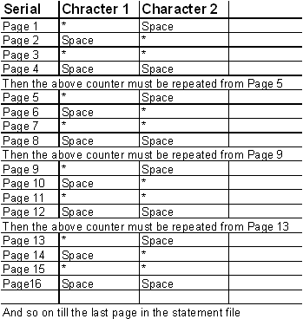
Also , regarding to the number of Trans. per page :
** If the page 1/1 or the last page >>> number of Trans.Up to 20 Trans. .
** Other >>> Up to 40 Trans.
I hope that MSCC finish these modification A.S.A.P in order to test before the Cycle .
Thanks and best regards
W.Samy
This message and any attachments (the "message") is
intended solely for the addressees and is confidential.
If you receive this message in error, please delete it and
immediately notify the sender. Any use not in accord with
its purpose, any dissemination or disclosure, either whole
or partial, is prohibited except formal approval. The internet
can not guarantee the integrity of this message.
BNP PARIBAS (and its subsidiaries) shall (will) not
therefore be liable for the message if modified.

---------------------------------------------

Ce message et toutes les pieces jointes (ci-apres le
"message") sont etablis a l'intention exclusive de ses
destinataires et sont confidentiels. Si vous recevez ce
message par erreur, merci de le detruire et d'en avertir
immediatement l'expediteur. Toute utilisation de ce
message non conforme a sa destination, toute diffusion
ou toute publication, totale ou partielle, est interdite, sauf
autorisation expresse. L'internet ne permettant pas
d'assurer l'integrite de ce message, BNP PARIBAS (et ses
filiales) decline(nt) toute responsabilite au titre de ce
message, dans l'hypothese ou il aurait ete modifie.

